ABDUL SHAHID AFRID SHAIK

*GitHub Repo URL: https://github.com/shahid 8256/bash-scripting-tasks

Task 1: Check Whether a Directory Exists
Objective:
Create a Bash script that checks whether a specified directory exists on the Amazon Linux EC2 server.
Script Name: task1.bash
Script:
#!/bin/bash

read -p "Enter directory path: " dir

if [ -d "$dir" ]
then
echo "Directory exists"
else
echo "Directory does not exist"
fi
Commands Used:
vi task1.bash
chmod +x task1.bash
./task1.bash
Working:
- read -p takes the directory path from the user.
- -d checks whether the specified path exists and is a directory.
- If the directory exists, the script displays Directory exists.
- If the directory does not exist, it displays Directory does not exist.
Testing:
Existing directory:
Enter directory path: /root
Directory exists
Non-existing directory:
Enter directory path: /abc123
Directory does not exist
Result:
The Bash script successfully checks whether the given directory exists on the Amazon Linux EC2 server.

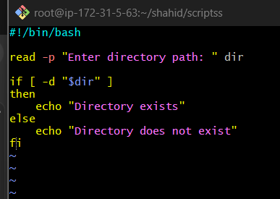

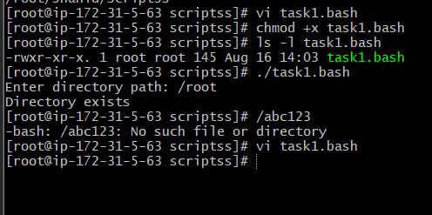

Task 2: Create Multiple Files Using Bash Script
Objective:
Create a Bash script that accepts the number of files and their names from the user and creates multiple files automatically.
Script Name: create_multiple_files.bash
Script:
#!/bin/bash

read -p "Enter number of files to create: " n

for ((i=1; i<=n; i++))
do
read -p "Enter file name $i: " filename
touch "$filename"
done

echo "Files created successfully"
Commands Used:
vi create_multiple_files.bash
chmod +x create_multiple_files.bash
./create_multiple_files.bash
Example Execution:
Enter number of files to create: 3
Enter file name 1: file1.txt
Enter file name 2: file2.txt
Enter file name 3: file3.txt
Files created successfully
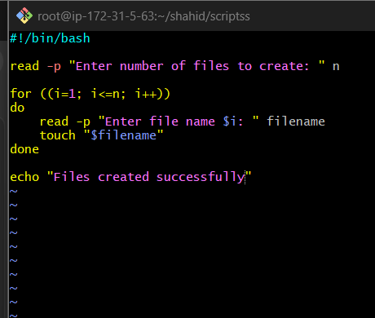

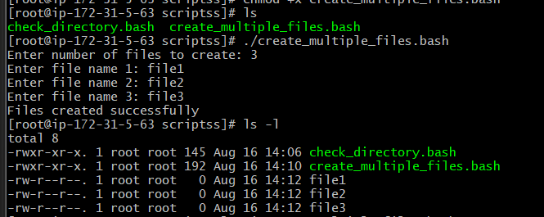

Task 3 — Backup a Directory
Use the descriptive script name:
backup_directory.bash
Step 1 — Create the script
You're working in:
/root/shahid/scripts
Run:
vi backup_directory.bash
Press i and enter:
#!/bin/bash

read -p "Enter directory to backup: " source_dir
read -p "Enter backup location: " backup_dir

if [ ! -d "$source_dir" ]
then
echo "Source directory does not exist"
exit 1
fi

mkdir -p "$backup_dir"

backup_file="$backup_dir/backup_$(date +%Y%m%d_%H%M%S).tar.gz"

tar -czf "$backup_file" "$source_dir"

echo "Backup created successfully: $backup_file"
Save:
Esc → :wq → Enter
Step 2 — Give execute permission
chmod +x backup_directory.bash
Step 3 — Create something to back up
For a safe test:
mkdir -p /root/shahid/testdata
echo "This is backup test data" > /root/shahid/testdata/file1.txt
echo "Another test file" > /root/shahid/testdata/file2.txt
Step 4 — Run the script
./backup_directory.bash
Enter:
Enter directory to backup: /root/shahid/testdata
Enter backup location: /root/shahid/backups
You should get something similar to:
Backup created successfully: /root/shahid/backups/backup_20260816_193500.tar.gz
The exact timestamp will be different.
Step 5 — Verify the backup
ls -lh /root/shahid/backups/
You should see the .tar.gz backup file.
To inspect its contents:
tar -tzf /root/shahid/backups/backup_*.tar.gz
What the important commands do
tar -czf
creates a compressed archive.
- c → create archive
- z → gzip compression
- f → specify the archive filename
date +%Y%m%d_%H%M%S
generates a timestamp such as:
20260816_193500
This makes each backup filename unique instead of overwriting an earlier backup.
Important
Don't use /root itself as your first test directory. Use /root/shahid/testdata as above. It keeps your practice controlled and avoids accidentally creating a huge backup.
Once this works, your screenshot should show the script execution and ls -lh showing the generated .tar.gz file.

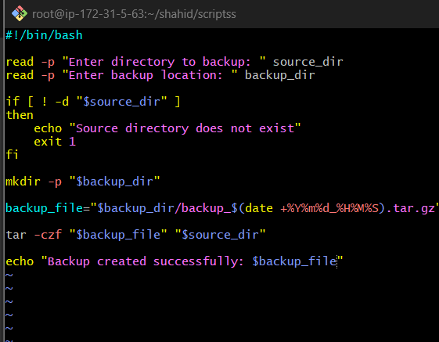

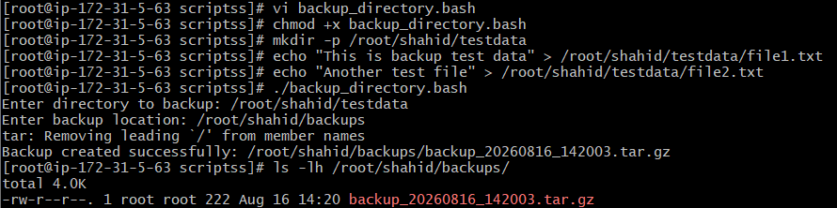

Task 4: Install Nginx on Amazon Linux EC2
Objective:
Create a Bash script to automatically install and start the Nginx web server on an Amazon Linux EC2 instance.
Script Name: install_nginx.bash
Script:
#!/bin/bash

echo "Installing Nginx..."

dnf install nginx -y

if [ $? -eq 0 ]
then
echo "Nginx installed successfully."
else
echo "Nginx installation failed."
exit 1
fi

systemctl enable nginx
systemctl start nginx

echo "Nginx service started successfully."
Commands Used:
vi install_nginx.bash
chmod +x install_nginx.bash
./install_nginx.bash
Working:
- #!/bin/bash specifies Bash as the script interpreter.
- dnf install nginx -y installs Nginx using the Amazon Linux package manager.
- $? stores the exit status of the previous command.
- 0 indicates that the installation was successful.
- systemctl enable nginx configures Nginx to start automatically after system boot.
- systemctl start nginx starts the Nginx service immediately.
- exit 1 terminates the script when installation fails.
Verification:
Check the Nginx service:
systemctl status nginx
Expected:
Active: active (running)
Check the installed version:
nginx -v
Nginx can also be tested through a browser using the EC2 instance's public IP address. Inbound TCP port 80 must be allowed in the EC2 security group.
Result:
The Bash script successfully automates the installation and startup of the Nginx web server on Amazon Linux EC2.

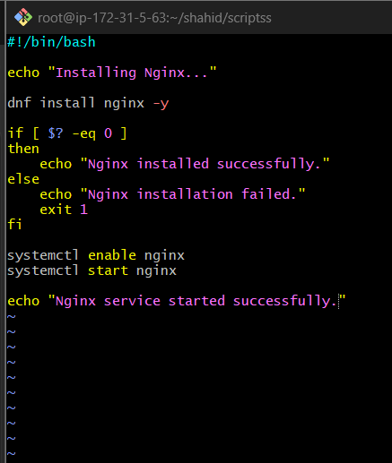
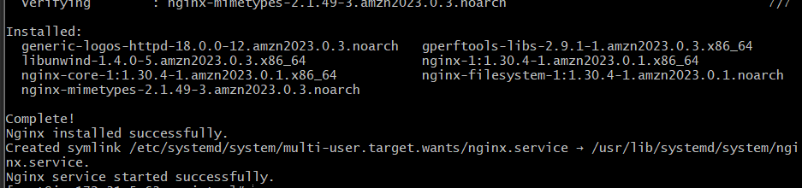

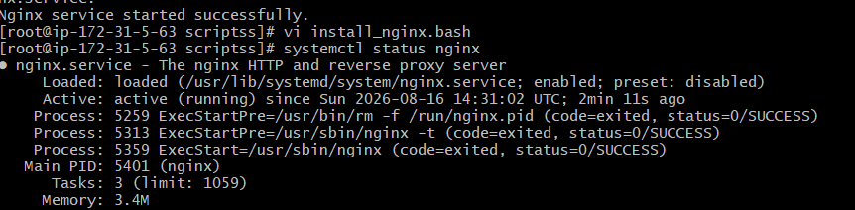

Task 5: Install Apache Tomcat on Amazon Linux EC2
Objective:
Create a Bash script to install Java, download and install Apache Tomcat 11.0.24, and start the Tomcat server on an Amazon Linux EC2 instance.
Script Name: install_tomcat.bash
Script:
#!/bin/bash

echo "Installing Java..."
dnf install java-17-amazon-corretto -y

echo "Downloading Tomcat 11.0.24..."
cd /opt

curl -O https://dlcdn.apache.org/tomcat/tomcat-11/v11.0.24/bin/apache-tomcat-11.0.24.tar.gz

echo "Extracting Tomcat..."
tar -xzf apache-tomcat-11.0.24.tar.gz

mv apache-tomcat-11.0.24 tomcat

chmod +x /opt/tomcat/bin/*.sh

echo "Starting Tomcat..."
/opt/tomcat/bin/startup.sh

echo "Tomcat installation completed."
Commands Used:
vi install_tomcat.bash
chmod +x install_tomcat.bash
./install_tomcat.bash
Working:
- dnf install java-17-amazon-corretto -y installs Java 17, which is required by Tomcat.
- cd /opt changes to the directory where Tomcat will be installed.
- curl -O downloads the Apache Tomcat 11.0.24 compressed archive.
- tar -xzf extracts the .tar.gz archive.
- mv renames the extracted Tomcat directory to /opt/tomcat.
- chmod +x gives execute permission to Tomcat's shell scripts.
- startup.sh starts the Tomcat server.
Verification:
Check the Tomcat installation:
ls -l /opt/tomcat
Check whether Tomcat is listening on port 8080:
ss -lntp | grep 8080
Tomcat can also be tested from a browser:
http:// 3.110.101.149:8080
TCP port 8080 must be allowed in the EC2 security group's inbound rules.
Result:
Apache Tomcat 11.0.24 was successfully installed and started on the Amazon Linux EC2 server using a Bash script.

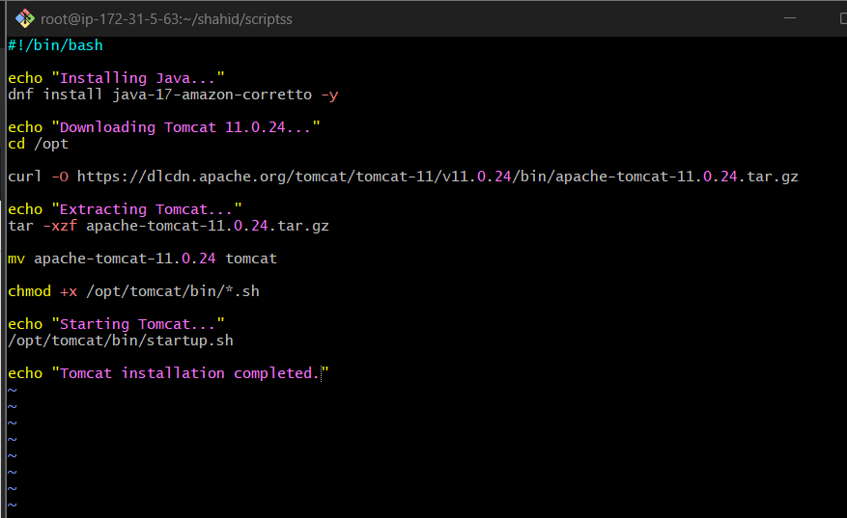
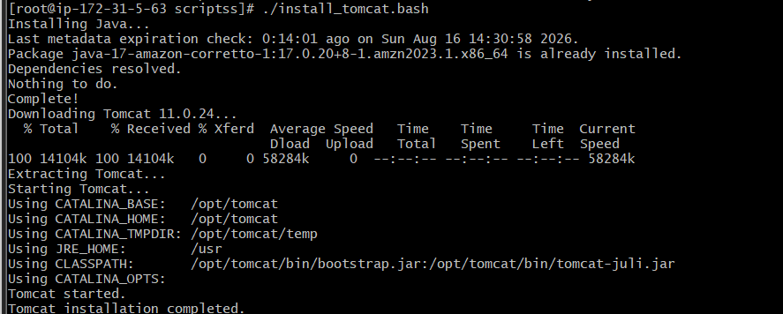

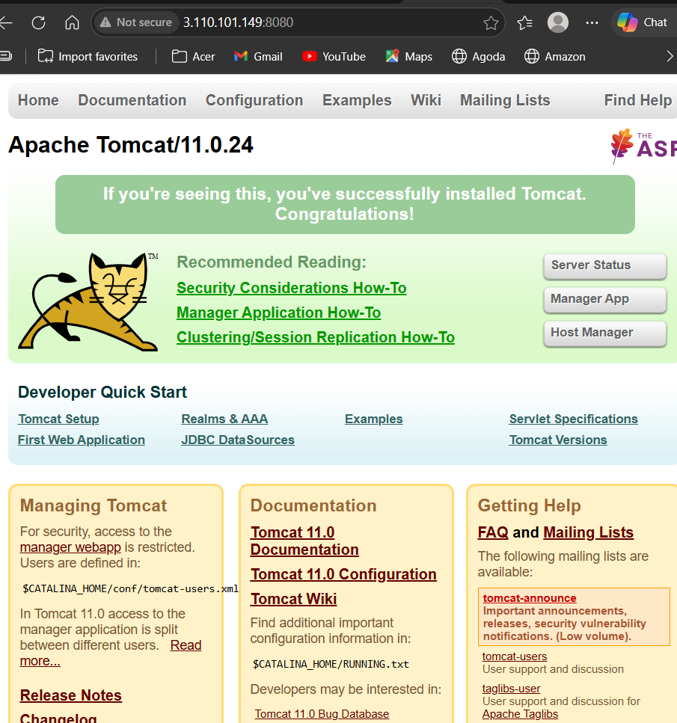

Task 6: Check Nginx Service and Start If Not Running
Objective:
Create a Bash script that checks whether the Nginx service is running. If Nginx is not running, the script automatically starts the service and verifies that it started successfully.
Script Name: check_and_start_nginx.bash
Script:
#!/bin/bash

if systemctl is-active --quiet nginx
then
echo "Nginx service is running."
else
echo "Nginx service is not running. Starting Nginx..."
systemctl start nginx

if systemctl is-active --quiet nginx
then
echo "Nginx service started successfully."
else
echo "Failed to start Nginx service."
exit 1
fi
fi
Commands Used:
vi check_and_start_nginx.bash
chmod +x check_and_start_nginx.bash
./check_and_start_nginx.bash
Working:
- systemctl is-active --quiet nginx checks whether the Nginx service is currently active.
- If Nginx is running, the script displays Nginx service is running.
- If Nginx is not running, systemctl start nginx starts the service.
- The script checks the service again after starting it.
- If the service still fails to start, exit 1 terminates the script with an error status.
Testing:
To test the stopped-service condition:
systemctl stop nginx
Run the script:
./check_and_start_nginx.bash
Expected output:
Nginx service is not running. Starting Nginx...
Nginx service started successfully.
Verify:
systemctl status nginx
Expected:
Active: active (running)
Result:
The Bash script successfully checks the Nginx service status and automatically starts Nginx when the service is not running.

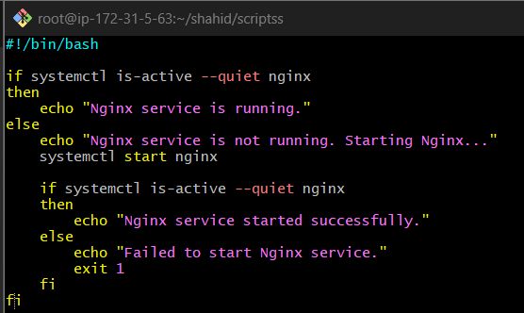
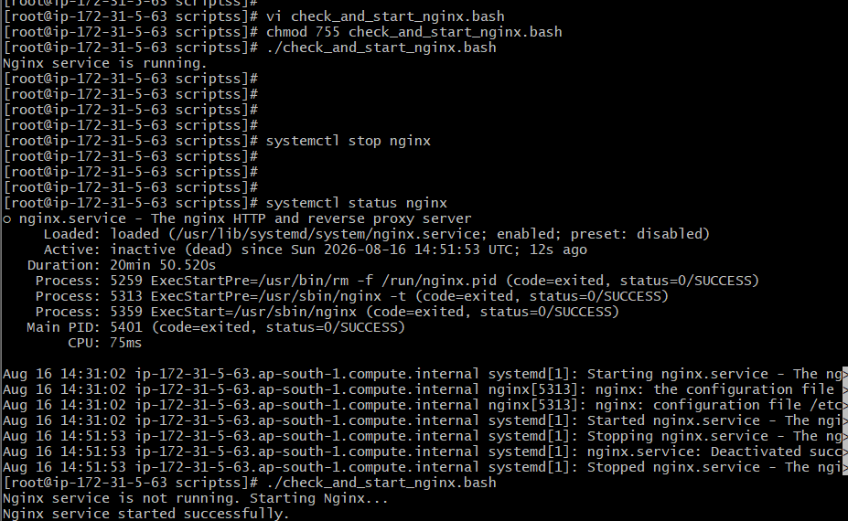

Task 7: Bash Calculator
Objective:
Create a Bash script that performs basic arithmetic operations based on the operator entered by the user.
Script Name: calculator.bash
Script:
#!/bin/bash

read -p "Enter first number: " num1
read -p "Enter second number: " num2
read -p "Enter operator (+, -, *, /): " operator

case $operator in
+) result=$((num1 + num2)) ;;
-) result=$((num1 - num2)) ;;
\*) result=$((num1 * num2)) ;;
/)
if [ "$num2" -eq 0 ]
then
echo "Cannot divide by zero."
exit 1
fi
result=$((num1 / num2))
;;
*) echo "Invalid operator."; exit 1 ;;
esac

echo "Result: $result"
Commands Used:
vi calculator.bash
chmod +x calculator.bash
./calculator.bash
Working:
- read accepts the first number, second number, and arithmetic operator.
- case compares the entered operator with +, -, *, and /.
- $(( )) performs integer arithmetic in Bash.
- The division condition checks whether the second number is zero to prevent division by zero.
- The default * case handles an invalid operator.
Example Execution:
Enter first number: 20
Enter second number: 5
Enter operator (+, -, *, /): *
Result: 100
Result:
The Bash calculator successfully performs addition, subtraction, multiplication, and division based on the user's selected operator.
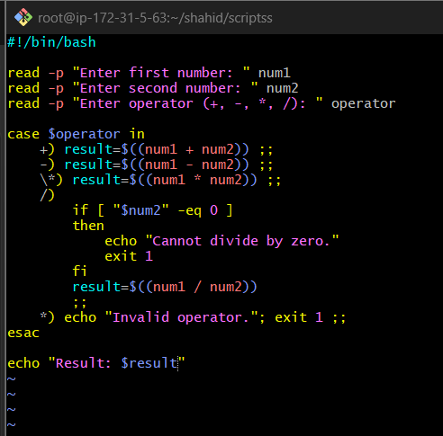

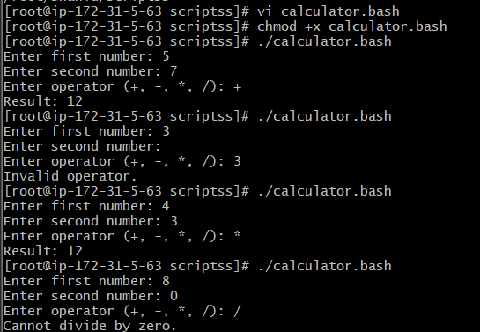

Task 8: Check and Create Directory If Missing
Objective:
Create a Bash script that checks whether a specified directory exists. If the directory does not exist, the script creates it.
Script Name: create_directory_if_missing.bash
Script:
#!/bin/bash

read -p "Enter directory path: " dir

if [ -d "$dir" ]
then
echo "Directory already exists."
else
mkdir -p "$dir"
echo "Directory created successfully."
fi
Commands Used:
vi create_directory_if_missing.bash
chmod +x create_directory_if_missing.bash
./create_directory_if_missing.bash
Working:
- read accepts the directory path from the user.
- [ -d "$dir" ] checks whether the specified directory exists.
- If the directory exists, the script displays Directory already exists.
- If the directory does not exist, mkdir -p creates the directory.
- mkdir -p also creates any missing parent directories in the specified path.
Example Execution — Directory Does Not Exist:
Enter directory path: /root/shahid/test_directory
Directory created successfully.
Example Execution — Directory Already Exists:
Enter directory path: /root/shahid/test_directory
Directory already exists.
Verification:
ls -ld /root/shahid/test_directory
Result:
The Bash script successfully checks for the existence of a directory and creates it automatically when it is not available.

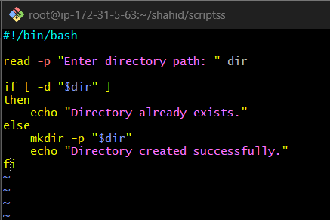
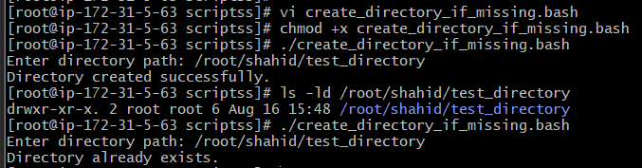

Task 9: Delete the Last 3 Lines of a File
Objective:
Create a Bash script that removes the last three lines from a specified file.
Script Name: delete_last_three_lines.bash
Script:
#!/bin/bash

read -p "Enter file path: " file

if [ ! -f "$file" ]
then
echo "File does not exist."
exit 1
fi

head -n -3 "$file" > temp_file
mv temp_file "$file"

echo "Last 3 lines deleted successfully."
Commands Used:
vi delete_last_three_lines.bash
chmod +x delete_last_three_lines.bash
./delete_last_three_lines.bash
Working:
- read accepts the file path from the user.
- [ ! -f "$file" ] checks whether the specified file exists.
- head -n -3 "$file" outputs all lines except the last 3 lines.
- The output is temporarily stored in temp_file.
- mv temp_file "$file" replaces the original file with the modified content.
Example:
Before execution:
Line 1
Line 2
Line 3
Line 4
Line 5
Line 6
Line 7
Line 8
Line 9
Line 10

After execution:
Line 1
Line 2
Line 3
Line 4
Line 5
Line 6
Line 7
Line 8

Verification:
cat testfile.txt
Result:
The Bash script successfully removes the last three lines from the specified file while retaining all preceding lines.

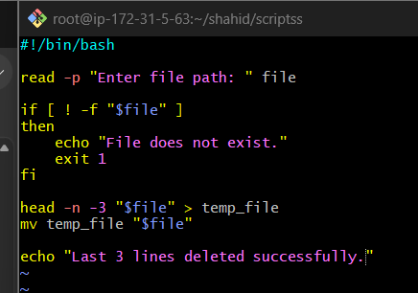
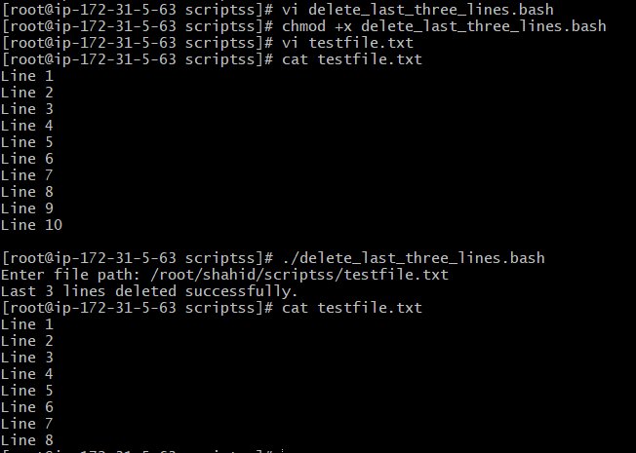

Task 10: Monitor CPU Usage and Send Email Notification
Objective:
Create a Bash script to monitor CPU utilization and send an email notification when CPU usage exceeds 80%.
Script Name: monitor_cpu.bash
#!/bin/bash

CPU=$(top -bn1 | awk -F',' '/Cpu\(s\)/ {
for (i=1; i<=NF; i++) {
if ($i ~ / id/) {
gsub(/[^0-9.]/, "", $i)
print 100 - $i
exit
}
}
}')

echo "Current CPU usage: $CPU%"

if awk "BEGIN {exit !($CPU > 80)}"
then
echo "CPU usage is above 80%."
echo "High CPU usage detected: $CPU%" | mail -s "CPU Alert" root
else
echo "CPU usage is normal."
Fi

For the documentation, the email section should say:
Email Notification:
When CPU utilization exceeds 80%, the script sends an alert email to the local root user using the mail command.
echo "High CPU usage detected: $CPU%" | mail -s "CPU Alert" root
The notification was verified by checking:
cat /var/spool/mail/root
This matches what you actually implemented and tested.
Task 10: Monitor CPU Usage and Send Email Notification
Objective:
Create a Bash script to monitor CPU utilization and send an email notification to the root user when CPU usage exceeds 80%.
Script Name: monitor_cpu.bash
Script:
#!/bin/bash

CPU=$(top -bn1 | awk -F',' '/Cpu\(s\)/ {
for (i=1; i<=NF; i++) {
if ($i ~ / id/) {
gsub(/[^0-9.]/, "", $i)
print 100 - $i
exit
}
}
}')

echo "Current CPU usage: $CPU%"

if awk "BEGIN {exit !($CPU > 80)}"
then
echo "CPU usage is above 80%."
echo "High CPU usage detected: $CPU%" | mail -s "CPU Alert" root
else
echo "CPU usage is normal."
fi
Commands Used:
vi monitor_cpu.bash
chmod +x monitor_cpu.bash
./monitor_cpu.bash
Working:
- top -bn1 obtains a single non-interactive snapshot of CPU statistics.
- awk searches dynamically for the CPU id (idle) value instead of assuming a fixed field number.
- 100 - idle calculates the current CPU utilization.
- The current CPU usage is displayed on the terminal.
- The if condition checks whether CPU usage is greater than 80%.
- If CPU usage exceeds 80%, the mail command sends an alert to the root user.
- If CPU usage is 80% or below, the script displays that CPU usage is normal.
Example Output:
Current CPU usage: 6.2%
CPU usage is normal.
When CPU usage exceeds the threshold:
Current CPU usage: 85.4%
CPU usage is above 80%.
Email Notification:
echo "High CPU usage detected: $CPU%" | mail -s "CPU Alert" root
- mail → sends the email.
- -s "CPU Alert" → sets the email subject.
- root → specifies the local root user as the recipient.
Verification:
The notification can be checked in the root user's local mailbox:
cat /var/spool/mail/root
The alert message should contain the CPU usage and the subject:
Subject: CPU Alert
Testing:
The threshold was temporarily lowered during testing to verify the alert condition and email notification. After testing, the threshold was restored to 80%.
Result:
The Bash script successfully monitors CPU utilization and sends an email notification to the root user when CPU usage exceeds 80%.

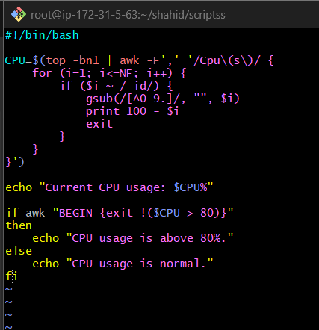

Changed that 80% to 1% to check that our script is working if the utilization part working or not ….just for checking purpose ….because we can modify or fake the cpu utilizations
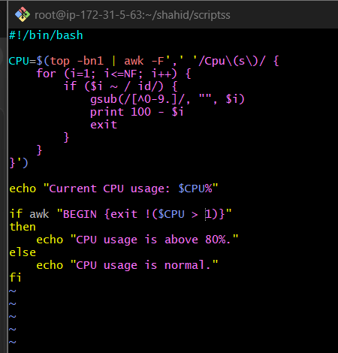
Till here I am just checking the monitoring and cup usage percentage .
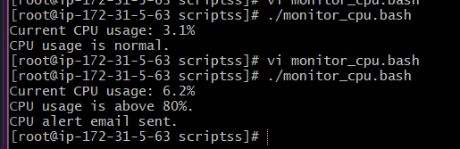

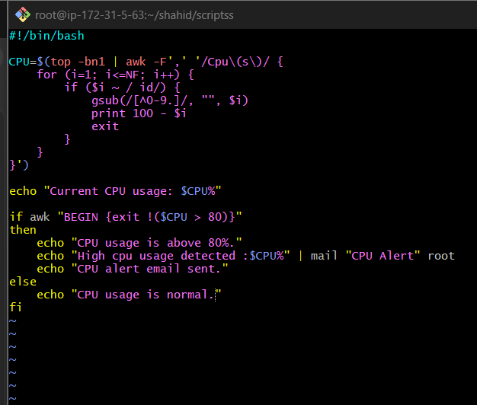
Script for sending email if CPU usage is more than 80%.
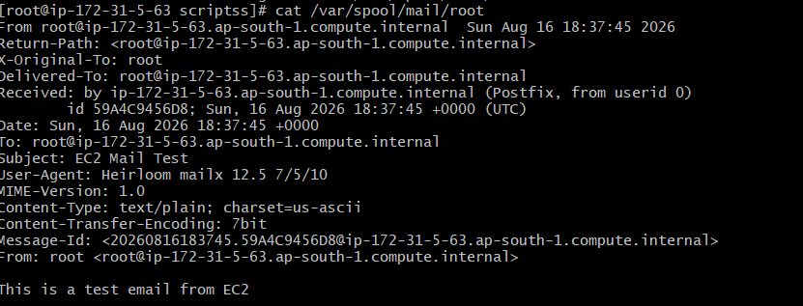
Figure :Mail to the root

Task 11: Monitor Disk Space and Send Email Notification
Objective:
Create a Bash script to monitor disk-space usage of the root filesystem (/). If disk usage exceeds 80%, the script sends an email notification to the local root user.
Script Name: monitor_disk.bash
Script:
#!/bin/bash

DISK=$(df -P / | awk 'NR==2 {gsub("%","",$5); print $5}')

echo "Current disk usage: $DISK%"

if [ "$DISK" -gt 80 ]
then
echo "Disk usage is above 80%."
echo "High disk usage detected: $DISK%" | mail -s "Disk Space Alert" root
else
echo "Disk usage is normal."
fi
Commands Used:
vi monitor_disk.bash
chmod +x monitor_disk.bash
./monitor_disk.bash
Working:
- df -P / displays disk-space information for the root filesystem.
- awk extracts the disk usage percentage from the output.
- gsub("%","",$5) removes the % symbol so the value can be used in a numeric comparison.
- The current disk usage is displayed using echo.
- The if condition checks whether disk usage is greater than 80%.
- If usage exceeds 80%, an email alert is sent to the local root user.
- If usage is 80% or below, the script displays that disk usage is normal.
Example Output:
Current disk usage: 26%
Disk usage is normal.
Email Notification:
echo "High disk usage detected: $DISK%" | mail -s "Disk Space Alert" root
- mail → sends the notification.
- -s "Disk Space Alert" → specifies the email subject.
- root → specifies the local root user as the recipient.
Verification:
The root mailbox can be checked using:
cat /var/spool/mail/root
The alert should contain:
Subject: Disk Space Alert
Testing:
The threshold was temporarily lowered to test the alert condition without actually filling the EC2 disk. After testing, the threshold was restored to 80%.
Result:
The Bash script successfully monitors disk-space usage and sends an email notification to the root user when disk usage exceeds 80%.

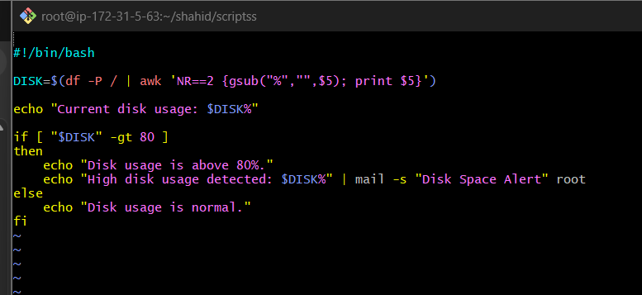
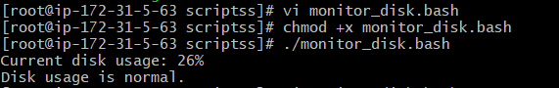

Just to verify is mail function working or not …..changing 80-10

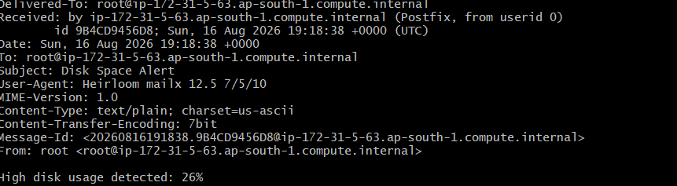

Task 12: Monitor Memory Usage and Send Email Notification
Objective:
Create a Bash script to monitor memory utilization. If memory usage exceeds 80%, the script sends an email notification to the local root user.
Script Name: monitor_memory.bash
Script:
#!/bin/bash

MEMORY=$(free | awk '/^Mem:/ {printf "%.0f", (($2-$7)/$2)*100}')

echo "Current memory usage: $MEMORY%"

if [ "$MEMORY" -gt 80 ]
then
echo "Memory usage is above 80%."
echo "High memory usage detected: $MEMORY%" | mail -s "Memory Alert" root
else
echo "Memory usage is normal."
fi
Commands Used:
vi monitor_memory.bash
chmod +x monitor_memory.bash
./monitor_memory.bash
Working:
- free displays the system's memory statistics.
- awk extracts the Mem: line from the output.
- $2 represents total memory.
- $7 represents available memory.
- ($2-$7) calculates memory that is currently unavailable.
- Dividing by total memory and multiplying by 100 calculates the memory usage percentage.
- The current memory usage is displayed using echo.
- The if condition checks whether memory usage is greater than 80%.
- If memory usage exceeds 80%, an email alert is sent to the local root user.
- Otherwise, the script displays that memory usage is normal.
Example Output:
Current memory usage: 51%
Memory usage is normal.
Email Notification:
echo "High memory usage detected: $MEMORY%" | mail -s "Memory Alert" root
- mail → sends the notification.
- -s "Memory Alert" → specifies the email subject.
- root → specifies the local root user as the recipient.
Verification:
Check the root user's mailbox:
cat /var/spool/mail/root
The alert should contain:
Subject: Memory Alert
Testing:
The threshold was temporarily lowered during testing to verify that the email alert was triggered. After testing, the threshold was restored to 80%.
Result:
The Bash script successfully monitors memory utilization and sends an email notification to the root user when memory usage exceeds 80%.

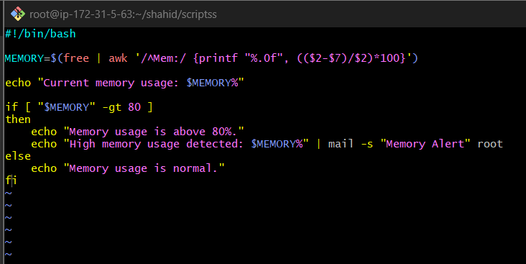


just to verify script 80 reduced to 20

